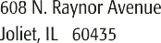
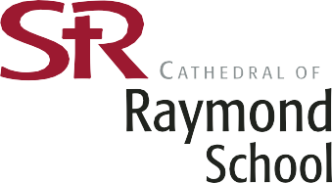

2019-2020 MILK ORDER FORM

2% WHITE MILK and CHOCOLATE MILK will be available from Monday August 26, 2019 until Friday May 22, 2020.

If you wish to order milk for your child, please complete the bottom portion of this form and return it, along with the required fee, no later than FRIDAY, August 23, 2019.

GRADES KINDERGARTEN - 8TH $ 36.00/YEAR

PRE-SCHOOL 3-DAY $ 21.00/YEAR

PRE-KINDERGARTEN 5-DAY $ 36.00/YEAR

IMPORTANT: PLEASE COMPLETE ONE FORM PER CHILD! MAKE YOUR CHECK PAYABLE TO ST. RAYMOND SCHOOL AND RETURN IN AN ENVELOPE MARKED *MILK FORM*.

------------------------------------------------------------------------------------------------------------------------------- PLEASE DETACH AND RETURN THIS PORTION
2019-2020 MILK ORDER FORM
*IMPORTANT: PLEASE COMPLETE 1 FORM PER CHILD*
YOU MAY WRITE 1 CHECK PER FAMILY

STUDENTS NAME:_____________________________________ GRADE:______

HOMEROOM:________ HOMEROOM TEACHER:_____________________________

PLEASE SELECT ONE:

_____ 2% WHITE MILK

_____ CHOCOLATE MILK

AMOUNT ENCLOSED: $____________

