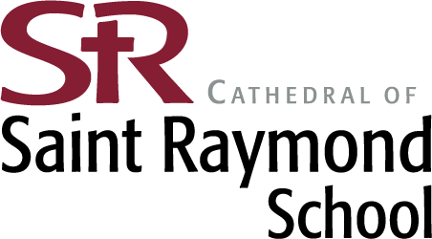

DATE: August 18, 2026

TO: Parent, Teachers and all other School Employees

FROM: Marjorie Hill, Principal

RE: Notification Letter Concerning Asbestos Content & Management Plan for Your School

Please be advised that the Asbestos Management Plan for the Cathedral of St. Raymond School required by 40 CFR 763.93 and the Illinois Asbestos Abatement Act is available for inspection during normal business hours by representatives of the U. S. Environmental Protection Agency and the State of Illinois, the public, including teachers, other school personnel, and their representatives, and parents at the following location: 608 N. Raynor Ave., Joliet, IL 60435.

During the summer of 2024, St. Raymond School underwent the required asbestos re-inspection process. The results of that are included in a document available from the school office. If our school conducted an asbestos removal project, that information is also contained in the asbestos management plan.

If you would like a copy of the asbestos management plan or other asbestos management documentation, please contact the Cathedral of St. Raymond School at 608 N. Raynor Ave., Joliet, IL. We will provide a copy within 5 working days after receipt of a request for inspection. The school may charge the reasonable cost of making any copies requested. If you have any questions about the school asbestos management plan or its contents, please contact the principal Marjorie Hill at 815-722-6626, business manager Pete Pluth at 815-722-6653 or Elena Cabral, the Diocese of Joliet asbestos designated person at 815-221-6195.

Sincerely,
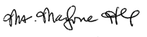

Ms. Marjorie Hill
Principal

